**OLA ANALYSIS**

**1. Retrieve all successful bookings:**

SELECT * FROM ola.bookings WHERE Booking_Status = 'Success';

**2. Find the average ride distance for each vehicle type:**

SELECT Vehicle_Type, AVG(Ride_Distance) as avg_distance FROM ola.bookings GROUP BY Vehicle_Type;

**Output:**

**3. Get the total number of cancelled rides by customers:**

SELECT COUNT(*) FROM ola.bookings WHERE Booking_Status = 'canceled by Customer';

**Output:**

**4. List the top 5 customers who booked the highest number of rides:**

SELECT Customer_ID, COUNT(Booking_ID) as total_rides FROM ola.bookings GROUP BY Customer_ID ORDER BY total_rides DESC LIMIT 5;

**Output:**

**5. Get the number of rides cancelled by drivers due to personal and car-related issues:**

SELECT COUNT(*) FROM ola.bookings WHERE canceled_Rides_by_Driver = 'Personal & Car related issue';

**Output:**

**6. Find the maximum and minimum driver ratings for Prime Sedan bookings:**

SELECT MAX(Driver_Ratings) as max_rating, MIN(Driver_Ratings) as min_rating FROM ola.bookings WHERE Vehicle_Type = 'Prime Sedan';

**Output:**

**7. Retrieve all rides where payment was made using UPI:**

SELECT * FROM ola.bookings WHERE Payment_Method = 'UPI';

**Output:**

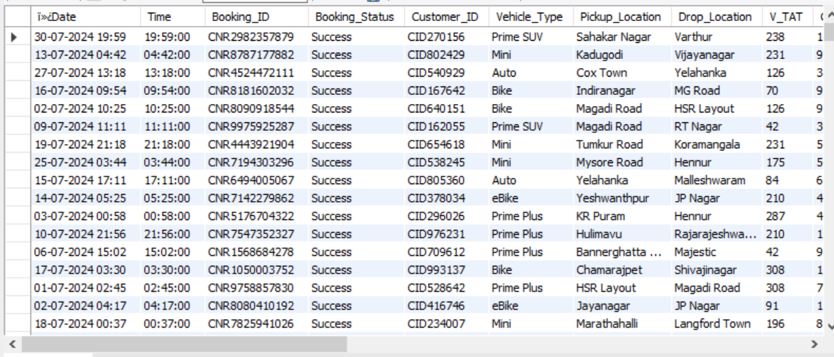

**8. Find the average customer rating per vehicle type:**

SELECT Vehicle_Type, AVG(Customer_Rating) as avg_customer_rating FROM ola.bookings GROUP BY Vehicle_Type;

**Output:**

**9. Calculate the total booking value of rides completed successfully:**

SELECT SUM(Booking_Value) as total_successful_value FROM ola.bookings WHERE Booking_Status = 'Success';

**Output:**

**10. List all incomplete rides along with the reason:**

SELECT Booking_ID, Incomplete_Rides_Reason FROM ola.bookings WHERE Incomplete_Rides ='Yes';

**Output:**

